Tree Induction
- Each model creates one tree per dataset
- Simply test the classification metrics
- First - impute missing values using preprocessing.py
- Make sure to use train/test split, in their code they used test_size=0.33
  - So classification accuracy should be on X_test
- After creating the .py files for the functions
  - (1) create automated script that goes through all the datasets, and all the models and creates a similar table like this, metrics are F1-score (macro average)
    - Need to repeat train/test split 5 times (no seed), and get 5 f1-macro values (report the median)
    - 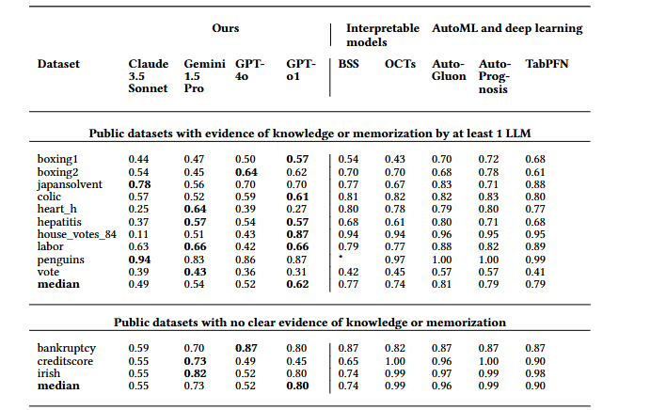
  - (3) create a boxplot per dataset that compares f1 scores (from the 5 repeated splits per model)
    - 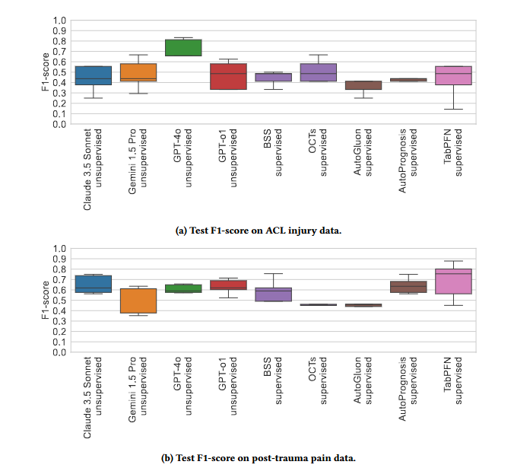

Tree Embeddings

